**Project Title:** Directory’s Permission management in Linux

**Objectives:**

* This project is to understand how to create a directory in Linux using CLI
* This project is to learn how to create a user in Linux using CLI
* This project is to learn how to change a directory’s permission for a user in Linux using CLI

**Methodology:**

Step 1: First I am creating a Directory in Linux using command **sudo** **mkdir /Alex**. Now a Directory has been created with name ‘Alex’. I can check the list of the Directories using command **ls /**

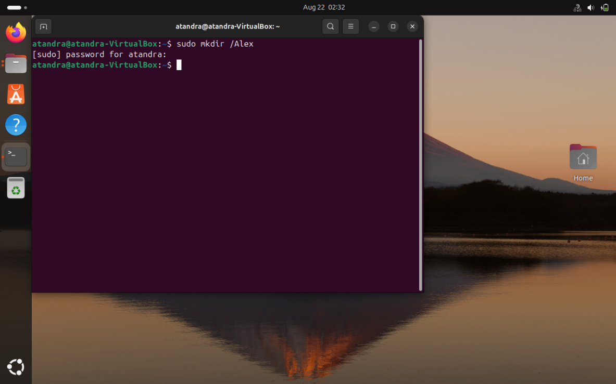

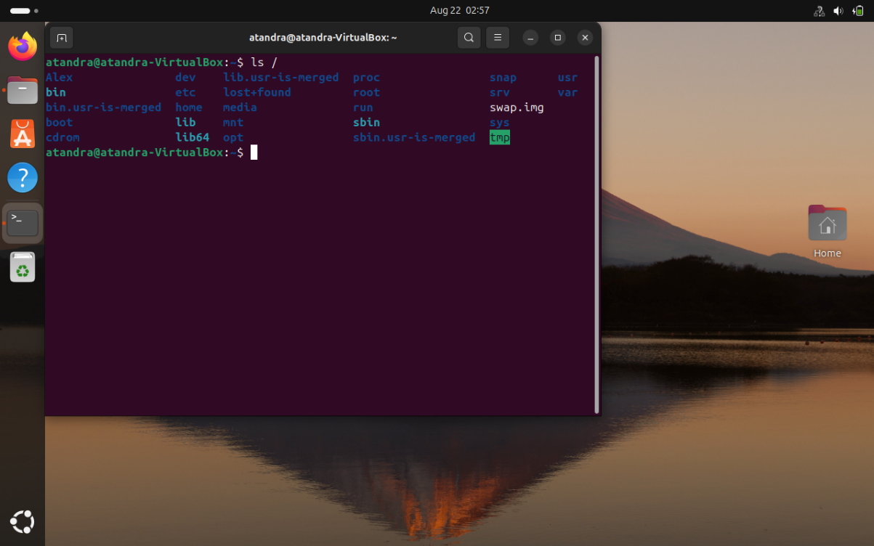

Step 2: Next I am creating a user with name ‘test’ using command **sudo adduser test.** Now I have to set a password for the new user and keep pressing Enter key**.** Now a user called ‘test’ is created. I can check the list of users using command **cat /etc/passwd**

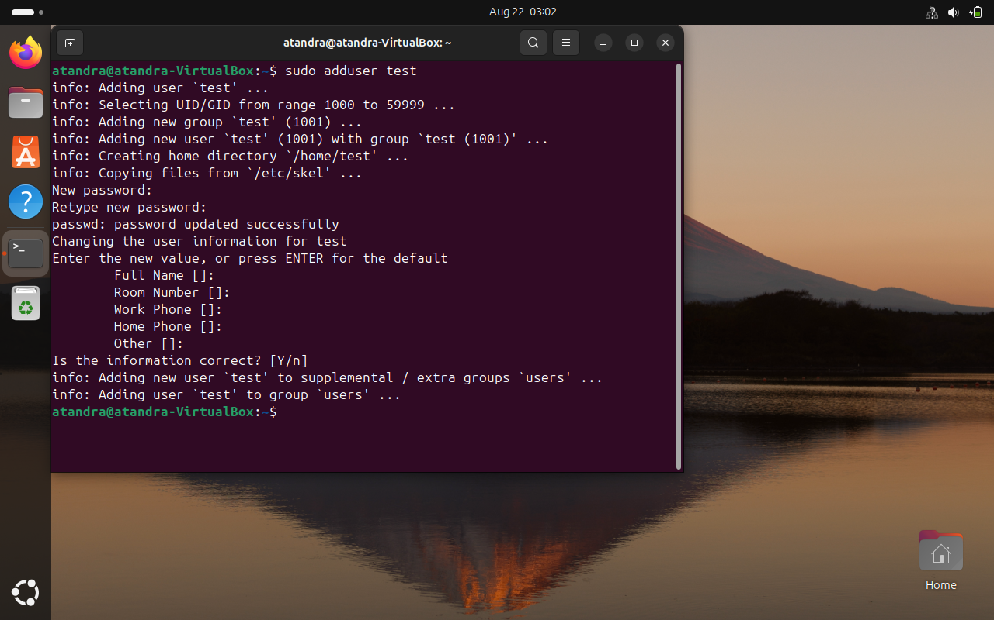

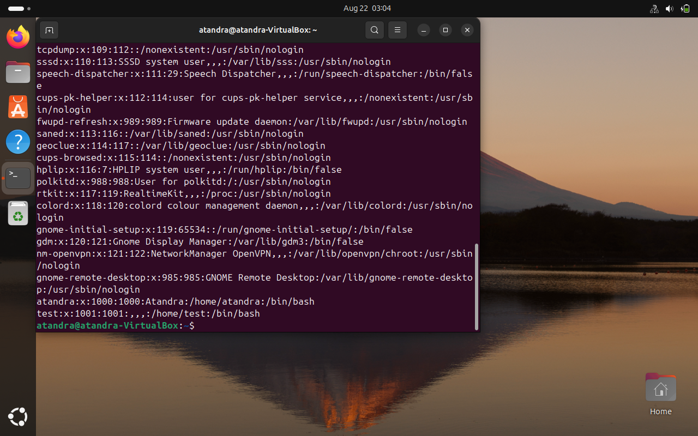

Step 3: Now I am changing ‘**Alex’** Directory’s permission in numerical format using command **sudo chmod 776 /Alex** . Here First digit 7 (4 for read + 2 for write + 1 for execute = 7 read, write, execute) is representing permissions for the ‘owner’ of the directory and by putting 7 I am giving read, write, execute permission to ‘owner’ of the directory.

Second digit is also 7 (4 for read + 2 for write + 1 for execute = 7 read, write, execute) which is representing permissions for the ‘group’ of the directory and by putting 7 I am giving read, write, execute permission to ‘group’ of the directory.

Third digit is 6 (4 for read + 2 for write + 0 for execute = 6 read, write) which is representing permission to ‘other users’ of the directory and by putting 6 I am giving read, write permission but denying execute permission to ‘other users’ of the directory.

When a new user is created then it belongs to the ‘other users’ so here **test** is belonging to the ‘other users’ list.

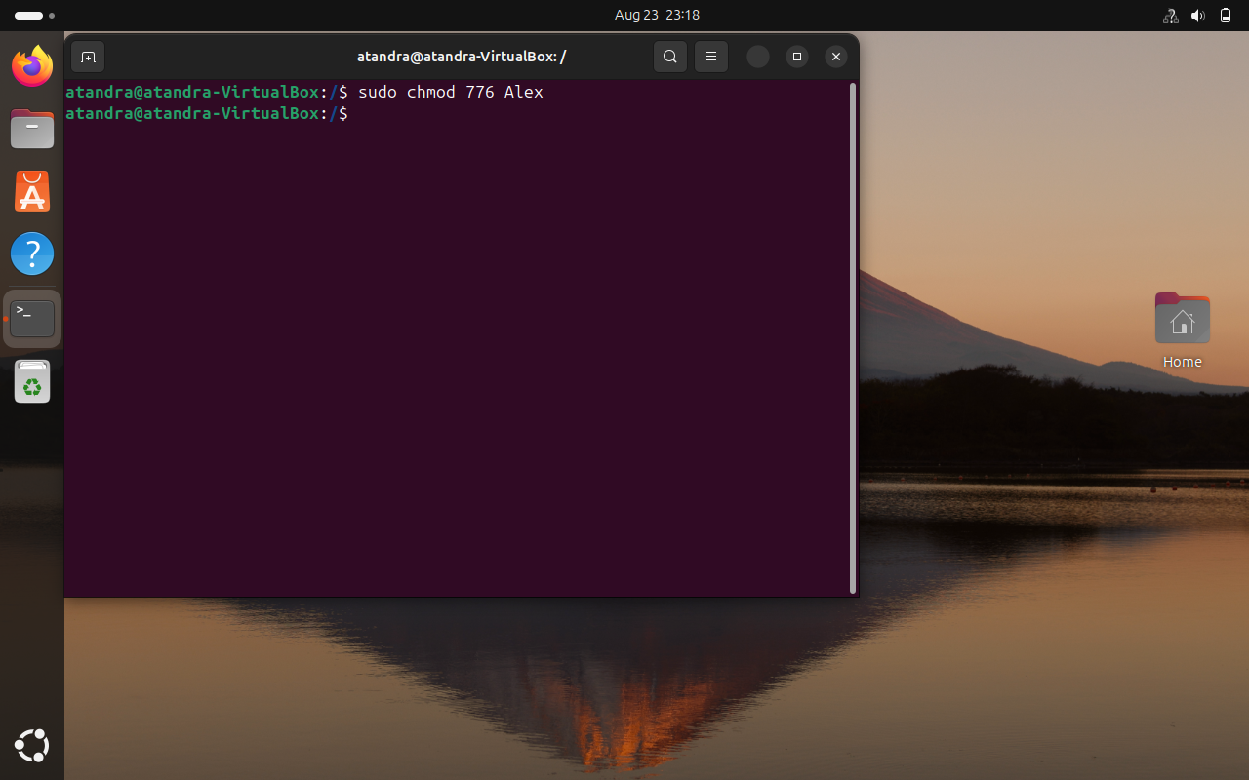

Step 4: Now I am checking the permission of the Directory **Alex** using command **ls -l /** . It will appear like this **drwxrwxrw- 2 root root** , here first alphabet **d** means it’s a directory, next three alphabet rwx (read, write, execute) is representing the permission for the ‘owner’ of the directory, second three alphabet rwx (read, write, execute) is representing the permission for the ‘group’ of the directory, last three rw- (read, write) is representing the permission for ‘other users’ of the directory so here read and write permission has been given but in execute section its blank that means execute permission has been denied for ‘other users’.

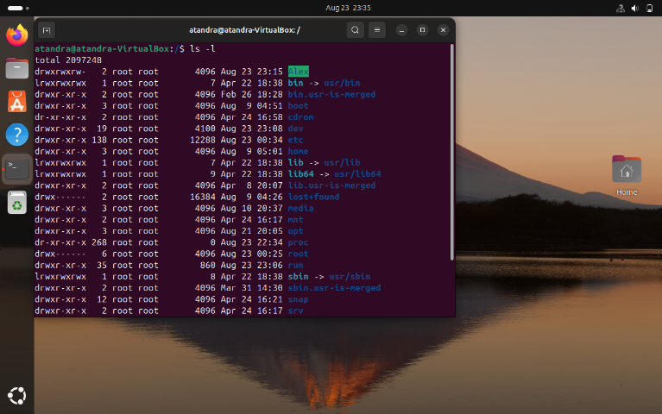

Step 5: Next I am logging into ‘test’ user using command **su test**

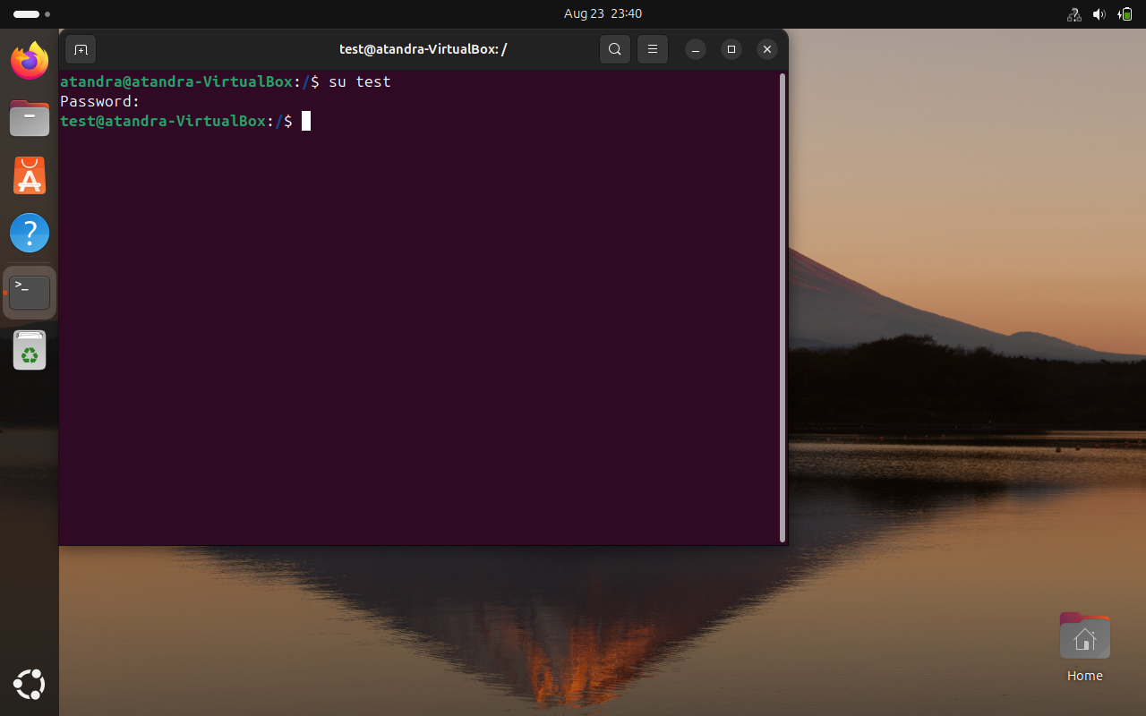

Step 6: Now I am navigating to ‘**Alex’** Directory using command **cd /Alex** and I am getting ‘permission denied' message here because Execute permission has been denied for ‘other users’ by Administrator user.

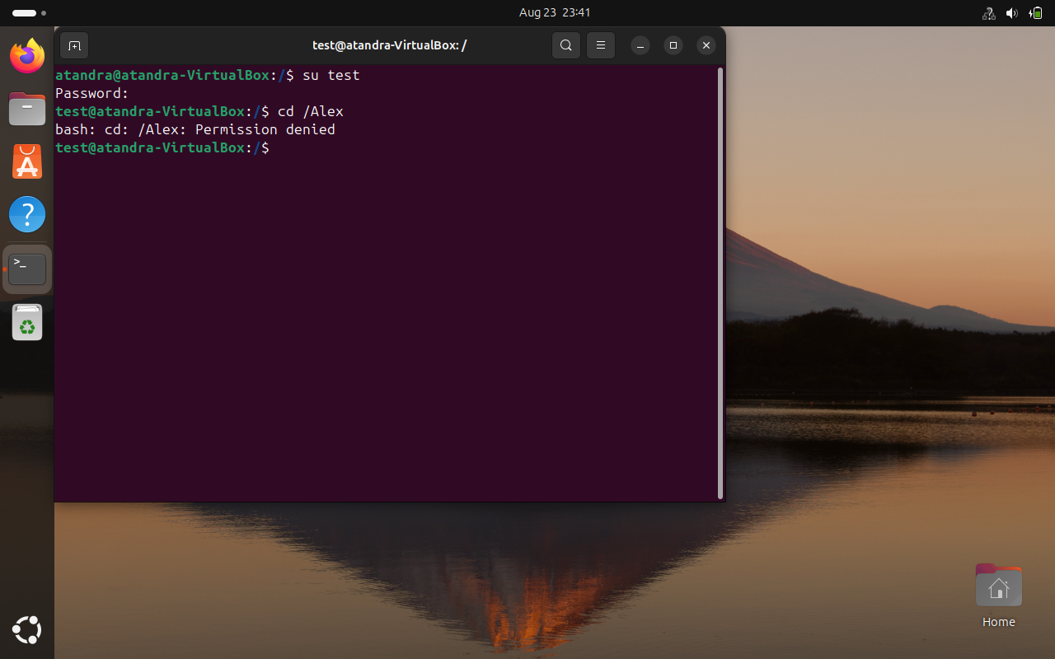

**Conclusion:**

This project has provided a comprehensive guide to changing permission of a directory for a user in Linux. By following the steps, you can create a new user and also you can change any directory permission.

This knowledge is important for IT professionals to manage their directory permissions for different users to prevent unauthorized access & accidental modifications of the directory, to maintain confidentiality of the directory.